Reonne Benoy

A00268832  MSc In Data Analytics, AIT

SQL Project

Relational Database

Concert Media pass

Table of Contents

1. Introduction 2

2. Original Data 3

Table Names 4

3. Entity-Relationship Diagram 7

4. Create Table Statements 8

5. Insert Statements 12

6. Tables 19

i. Venue 19

ii. Newspaper 19

iii. Sponsor 19

iv. Journalist 20

v. Concert 20

vi. Concert_Pass 21

7. Queries 22

# Introduction

The aim of the project was to examine all the data in relation to Concert media passes and then prepare it, in order to build a database using Oracle SQL. The table names and column names were supplied and hence, the initial steps were to find the relationships between each entity. We do this through the Entity-Relationship diagram. We populate the attributes of the entity and outline the Primary Key and Foreign Keys in each table.

Once the data was prepared, it was then implemented into Oracle SQL. We use create table statements and Insert statements so that the database is prepared and populated. The database with values is now ready for manipulation and data retrieval.

We will be using the following aspects of SQL commands in the document:

Data Manipulation Language (DML) – Insert, Updates, Deletes

Data Description Language (DDL)- Create, Alter, Drop

Select Statements for retrieving data from the database for the required conditions and necessities. We use single table queries, multiple table queries, join queries, summary query, Views.

# Original Data

|  |  |  |
| --- | --- | --- |
| **3** | **Concert_Media_Passes** | **CMP** |

Journalists from the newspaper sector of the media are allocated a certain amount of free passes so that they can attend and write articles about concerts they attend. A DB is required to store details about the journalists, the concerts etc.

Key assumptions: A venue may host many concerts. A Newspaper may employ many journalists. A journalist may obtain many concert passes *(may attend may concerts*). A sponsor may sponsor many concerts.

**A venue may hold many concerts and a concert is held at one and only one venue**

**A journalist may be granted many concert passess and a concert pass is assigned to one and only one journalist**

**A concert may permit many concert passes and a concert pass applies to one and only one concert**

**A newspaper may employ many journalists and a journalist is employed by a single newspaper**

**A sponsor may fund many concerts and is concert will be fiananced by one and only one sponsor**

**Venue** (**Venue_Id**, Name, Address, City, Country, Category (*Indoor, Outdoor*), Type (*All Seater, Terrace, Covered*), Year_Built, Cost, Capacity *(i.e. how many people the venue can hold*), Email, Web_Site)

**Journalist** (**Journalist_Id**, Forename, Surname, Address, Town, County, Gender, Date_Of_Birth, Qualifications (*BSC, B Comm, BA, B Eng*), Media_Sector (*Print Media, Internet Publications, Television, Radio etc*), Email_Address, Twitter_Username, Annual_Earnings, **Newspaper_Id**)

**Concert** (**Concert_Id**, Concert_Date, Group (*i.e. name of band or group)*, Category (*Pop, Rock, Classical*), Start_Time, Capacity, Expected_Attendance, Actual_Attendance, Ticket_Price, **Venue_Id**, **Sponsor_Id**, Sponsorship_Amount, Atmosphere (*Poor, Good, Superb*))

**Newspaper** (**Newspaper_Id**, Name, Address, Town, County, Year_Founded, Category (*Tabloid, Broadsheet)*, Email, Web_Site_Address, Annual_Turnover)

**Concert_Pass (Concert_Id, Journalist_Id**, Seat_Number, Priviliges (*Access all areas, Tea and Coffee, Hot Food etc.*)

**Sponsor** (**Sponsor_Id**, Name, Address, Town, County, Tel_No, Web_Site, Business_Type (*Finance, Manufacturing, Media*), Sponsorship_Budget)

## Table Names

1. Venue
2. Newspaper
3. Sponsor
4. Concert
5. Journalist
6. Concert_Pass

**Table: Venue**

Venue_Id

Name

Address

City

Country

Category

Type

Year_Built

Cost

Capacity

Email

Web_Site

**Table: Newspaper**

Newspaper_Id

Name

Address

Town

County

Year_Founded

Category

Email

Web_Site_Address

Annual_Turnover

**Table: Sponsor**

Sponsor_Id

Name

Address

Town

County

Tel_No

Web_Site

Business_Type

Sponsorship_Budget

**Table: Concert**

Concert_Id

Concert_Date

Group

Category

Start_Time

Capacity

Expected_Attendance

Actual_Attendance

Ticket_Price

Venue_Id

Sponsor_Id

Sponsorship_Amount

Atmosphere

**Table: Journalist**

Journalist_Id

Forename

Surname

Address

Town

County

Gender

Date_Of_Birth

Qualifications

Media_Sector

Email_Address

Twitter_Username

Annual_Earnings

Newspaper_Id

**Table: Concert_Pass**

Concert_Id

Journalist_Id

Seat_Number

Priviliges

*The underlined attributes are primary keys.*

# Entity-Relationship Diagram

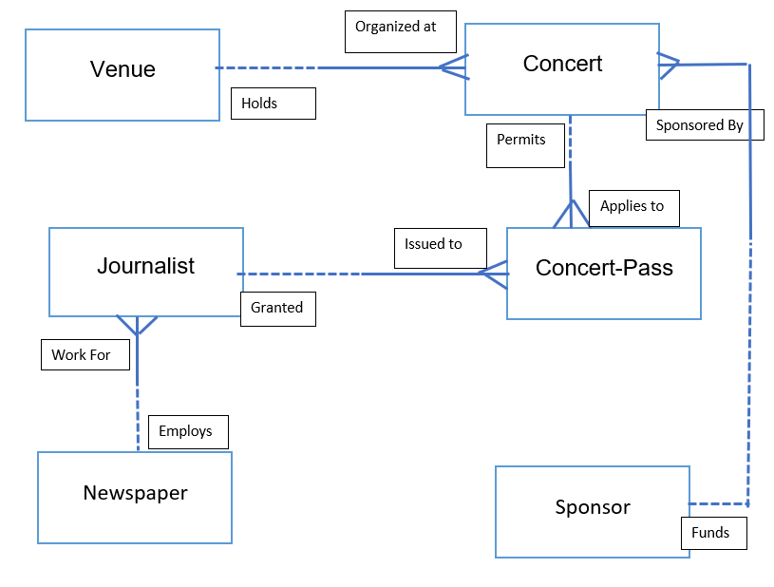

# Create Table Statements

Drop Table Venue;

Drop Table Concert;

Drop Table Journalist;

Drop Table Concert Pass;

Drop Table Newspaper;

Drop Table Sponsor;

Create Table Venue (

Venue_Id Number(2) Not Null,

Name Varchar2(28) Not Null,

Address Varchar2(22) Not Null,

City Varchar2(14) Not Null,

Country Varchar2(7) Not Null,

Category Varchar2(7) Not Null,

Type Varchar2(10) Not Null,

Year_Built Varchar2(4) Not Null,

Cost Number(9,2) Not Null,

Capacity Number(4) Not Null,

Email Varchar2(28) Not Null,

Web_Site Varchar2(73) Not Null,

Constraint Venue_Venue_Id_Pk Primary Key(Venue_Id),

Constraint Venue_Category_Ck Check(Category In (‘Indoor’, ‘Outdoor’)),

Constraint Venue_Type_Ck Check(Type In (‘All Seater’, ‘Terrace’, ‘Covered’)),

Constraint Venue_Email_Uq Unique(Email),

Constraint Venue_Web_Site_Uq Unique(Web_Site));

Create Table Newspaper(

Newspaper_Id Number(8) Not Null,

Name Varchar2(9) Not Null,

Address Varchar2(11) Not Null,

Town Varchar2(8) Not Null,

County Varchar2(9) Not Null,

Year_Founded Number(4) Not Null,

Category Varchar2(10) Not Null,

Email Varchar2(28) Not Null,

Web_Site_Address Varchar2(60) Not Null,

Annual_Turnover Decimal(7,2) Not Null,

Constraint Newspaper_Newspaper_Id_Pk Primary Key(Newspaper_Id),

Constraint Newspaper_Category_Ck Check(Category In ('Tabloid','Broadsheet')),

Constraint Newspaper_Email_Uq Unique(Email),

Constraint Newspaper_Web_Site_Address_Uq Unique(Web_Site_Address));

Create Table Sponsor(

Sponsor_Id Number(4) Not Null,

Name Varchar2(18) Not Null,

Address Varchar2(19) Not Null,

Town Varchar2(7) Not Null,

County Varchar2(9) Not Null,

Tel_No Number(10) Not Null,

Web_Site Varchar2(66) Not Null,

Business_Type Varchar2(13) Not Null,

Sponsorship_Budget Number(5) Not Null,

Constraint Sponsor_Sponsor_Id_Pk Primary Key(Sponsor_Id),

Constraint Sponsor_Tel_No_Uq Unique(Tel_No),

Constraint Sponsor_Web_Site_Uq Unique(Web_Site),

Constraint Sponsor_Business_Type_Ck Check(Business_Type In (‘Finance’, ‘Manufacturing’, ‘Media’)));

Create Table Journalist(

Journalist_Id Number(9) Not Null,

Forename Varchar2(12) Not Null,

Surname Varchar2(11) Not Null,

Address Varchar2(22) Not Null,

Town Varchar2(8) Not Null,

County Varchar2(11) Not Null,

Gender Varchar2(6) Not Null,

Date_Of_Birth Date Not Null,

Qualifications Varchar2(6) Not Null,

Media_Sector Varchar2(21) Not Null,

Email_Address Varchar2(26) Not Null,

Twitter_Username Varchar2(13) Not Null,

Annual_Earnings Decimal(9,2) Not Null,

Newspaper_Id Number(8) Not Null,

Constraint Journalist_Journalist_Id_Pk Primary Key(Journalist_Id),

Constraint Journalist_Gender_Ck Check(Gender In (‘Male’, ‘Female’),

Constraint Journalist_Qualifications_Ck Check(Qualifications In (‘BSC’, ‘B Comm’, ‘BA’, ‘B Eng’)),

Constraint Journalist_Media_Sector_Ck Check(Media_Sector In (‘Print Media’, ‘Internet Publications’, ‘Television’, ‘Radio’, ‘Podcast’)),

Constraint Journalist_Email_Address_Uq Unique(Email_Address),

Constraint Journalist_Twitter_Username_Uq Unique(Twitter_Username),

Constraint Journalist_Newspaper_Id_Fk Foreign Key(Newspaper_Id) References Newspaper(Newspaper_Id));

Create Table Concert(

Concert_Id Number(3) Not Null,

Concert_Date Date Not Null,

Group_Name Varchar2(15) Not Null,

Category Varchar2(9) Not Null,

Start_Time Varchar2(5) Not Null,

Capacity Number(4) Not Null,

Expected_Attendance Number(4) Not Null,

Actual_Attendance Number(4) Not Null,

Ticket_Price Number(4,2),

Venue_Id Number(2),

Sponsor_Id Number(4),

Sponsorship_Amount Number(8,2),

Atmosphere Varchar2(6),

Constraint Concert_Concert_Id_Pk Primary Key(Concert_Id),

Constraint Concert_Category_Ck Check(Category In (‘Pop’, ‘Rock’, ‘Classical’)),

Constraint Concert_Venue_Id_Fk Foreign Key(Venue_Id) References Venue(Venue_Id),

Constraint Concert_Sponsor_Id_Fk Foreign Key(Sponsor_Id) References Sponsor(Sponsor_Id),

Constraint Concert_Atmosphere_Ck Check(Atmosphere In (‘Poor’, ‘Good’, ‘Superb’)));

Create Table Concert_Pass(

Concert_Id Number(3) Not Null,

Journalist_Id Number(9) Not Null,

Seat_Number Varchar2(3) Not Null,

Priviledges Varchar2(15) Not Null,

Constraint Concert_Pass_ConJourn_Id_Pk Primary Key(Concert_Id,Journalist_Id),

Constraint Concert_Pass_Seat_Number_Uq Unique(Seat_Number),

Constraint Concert_Journalist_Id_Fk Foreign Key(Journalist_Id) References Journalist(Journalist_Id));

# Insert Statements

/* Table: Venue */

/* Venue_Id,Name,Address,City,Country,Category,Type,Year_Built, Cost ,Capacity,Email,Web_Site */

Insert into Venue values(1,'Douglas Brakus','78 Kingsford Terrace','Kinnegad','Ireland','Outdoor','All Seater',1993,7337351.00,8000,'rslegg0@flavors.me','http://sogou.com/ipsum/praesent/blandit/lacinia/erat/vestibulum.aspx?');

Insert into Venue values(2,'Jerde, Rosenbaum and Moen','47 Spaight Road','Ashford','Ireland','Indoor','Terrace',1996,8555789.00,5000,'nohagirtie1@patch.com','http://samsung.com/elementum/nullam/varius/nulla/facilisi/cras.jpg?');

Insert into Venue values(3,'Reichert-Hayes','555 Holmberg Drive','Ballyjamesduff','Ireland','Indoor','Terrace',1999,4911065.00,6000,'bmacknight2@friendfeed.com','https://statcounter.com/amet/nulla/quisque.xml?');

Insert into Venue values(4,'Leffler, Schmeler and Parker','3676 Rockefeller Drive','Ardee','Ireland','Outdoor','Terrace',2013,950535.00,6000,'nworthy3@chronoengine.com','https://friendfeed.com/in.aspx?');

Insert into Venue values(5,'Ratke-Denesik','6 Porter Road','Clondalkin','Ireland','Outdoor','Covered',1990,4576545.00,6000,'sscholtz4@multiply.com','http://tripadvisor.com/vivamus/vestibulum/sagittis/sapien/cum/sociis.png?');

Insert into Venue values(6,'Runolfsdottir LLC','711 Pierstorff Avenue','Sallins','Ireland','Outdoor','Covered',1996,7392883.00,7000,'cthursfield5@youtu.be','https://ycombinator.com/metus.aspx?');

Insert into Venue values(7,'Rogahn, Lind and Jerde','319 New Castle Point','Gorey','Ireland','Outdoor','Terrace',1997,1857729.00,7500,'seste6@netlog.com','https://nyu.edu/urna.jsp?');

Insert into Venue values(8,'Flatley, Davis and Kertzmann','978 Grasskamp Point','Carrigtwohill','Ireland','Outdoor','Terrace',2003,4652687.00,8000,'kspaven7@geocities.com','https://prlog.org/morbi/sem/mauris/laoreet/ut/rhoncus.jpg?');

Insert into Venue values(9,'Satterfield-Grady','9 Banding Way','Granard','Ireland','Outdoor','Terrace',2002,5866156.00,5050,'wcroose8@wunderground.com','http://ask.com/et/ultrices/posuere/cubilia.html?');

Insert into Venue values(10,'Veum, Parisian and Kuvalis','5426 Vera Place','Tullyallen','Ireland','Outdoor','Covered',2009,8633599.00,5000,'amachoste9@earthlink.net','http://sphinn.com/pede/venenatis.aspx?');

Insert into Venue values(11,'Blick, Herman and Schumm','2 Hermina Plaza','Tullamore','Ireland','Indoor','Covered',1992,2339242.00,6500,'rmeralia@deliciousdays.com','https://ustream.tv/ante/vel/ipsum/praesent/blandit/lacinia.jsp?');

Insert into Venue values(12,'Ondricka LLC','95761 Hayes Plaza','Cluain Meala','Ireland','Indoor','All Seater',1984,3119459.00,7600,'rkratesb@pen.io','https://chron.com/consectetuer/adipiscing/elit/proin/interdum.js?');

Insert into Venue values(13,'Haley-Feeney','53 Oak Plaza','Laoghaire','Ireland','Indoor','All Seater',2006,9599903.00,8100,'rtattonc@addtoany.com','http://blogtalkradio.com/maecenas/pulvinar/lobortis/est/phasellus.jsp?');

Insert into Venue values(14,'Roob, Treutel and Smith','7167 Lakewood Lane','Macroom','Ireland','Indoor','All Seater',2012,3282001.00,6000,'bcayzerd@google.com','http://list-manage.com/vestibulum/ante/ipsum/primis/in/faucibus.xml?');

Insert into Venue values(15,'Koepp Inc','46861 Grover Place','Cloyne','Ireland','Outdoor','Terrace',2012,2740611.00,7000,'lbiskupeke@apple.com','https://answers.com/massa/quis/augue/luctus/tincidunt/nulla/mollis.jpg?');

Insert into Venue values(16,'Williamson and Sons','08610 Macpherson Place','Cork','Ireland','Indoor','Terrace',2002,5246363.00',8900,'tcattof@narod.ru,https://exblog.jp/in.jsp?');

Insert into Venue values(17,'Terry-Harris','569 Lawn Hill','Cluain Meala','Ireland','Outdoor','All Seater',2006,1983072.00,7700,'blinceyg@soup.io','http://shinystat.com/posuere.js?');

Insert into Venue values(18,'Parker-Boyer','1 Barby Way','Laoghaire','Ireland','Outdoor','Covered',1996,'8927549.00,9000,'cespinheirah@dagondesign.com','http://forbes.com/at/vulputate/vitae/nisl/aenean.png?');

Insert into Venue values(19,'Wilderman Group','89420 Mayer Hill','Piltown','Ireland','Outdoor','All Seater',1984,2330796.00,4500,'bshafieri@webeden.co.uk','http://csmonitor.com/ac/diam.json?');

Insert into Venue values(20,'Wehner-Wolf','9658 Browning Hill','Mullagh','Ireland','Indoor','Terrace',1992,8249974.00,7000,'bbecklesj@oakley.com','https://google.com.au/in/felis/donec/semper/sapien/a/libero.js?');

/*Table: Newspaper */

/* Newspaper_Id,Name,Address,Town,County,Year_Founded,Category,Email,Web_Site_Address, Annual_Turnover */

Insert into Newspaper Values (46906910, ‘Holdlamis’, ‘Fairfield’, ‘Athlone’, ‘Cavan’,1972, ‘Broadsheet’, ‘bfowler0@dagondesign.com’, ‘https://furl.net/cras/pellentesque/volutpat/dui/maecenas.png’, 29793.59 )

Insert into Newspaper Values (98082914, ‘Alpha’, ‘Sommers’, ‘Arvagh’, ‘Clare’,2009, ‘Tabloid’, ‘rtolomio1@cocolog-nifty.com’, ‘http://chronoengine.com/vestibulum/ante/ipsum/primis/in.json’,74,724.97 )

Insert into Newspaper Values (62415463, ‘Span’, ‘Westport’, ‘Waterloo’, ‘Cavan’,2009, ‘Tabloid’,’grelfe2@hibu.com’, ‘http://whitehouse.gov/eleifend/luctus/ultricies.jpg’,46,138.59 )

Insert into Newspaper Values (25285988, ‘Sub-Ex’, ‘Merchant’, ‘Ardue’, ‘Westmeath’,2008, ‘Tabloid;, ‘lskule3@woothemes.com’, ‘https://dagondesign.com/lectus/aliquam.js’, 84,265.89)

Insert into Newspaper Values (44564546, ‘Konklux’, ‘Briar Crest’, ‘Waterloo’, ‘Cavan’,1996, ‘Broadsheet,ntrodler4@earthlink.net’, ‘http://scientificamerican.com/quis/turpis/sed.xml’,40,196.77 )

/*Table: Sponsor */

/* Sponsor_Id,Name,Address,Town,County,Tel_No,Web_Site,Business_Type,Sponsorship_Budget */

Insert Into Sponsor Values (4151, ‘Carolee Ludwell’, ‘5 Warner Parkway’, ‘Athlone’, ‘Clare’,805603204, ‘https://abc.net.au/luctus/nec/molestie/sed.aspx’, ‘Finance’,62834);

Insert Into Sponsor Values (4941, ‘Catherine Batstone’, ‘8 Scoville Drive’, ‘Ardue’, ‘Westmeath’,869186672, ‘https://boston.com/justo/in/hac/habitasse.js’, ‘Media’,85922);

Insert Into Sponsor Values (6184, ‘Patton Palombi’, ‘50 Gerald Way’, ‘Annagh’, ‘Westmeath’,818654231, ‘https://bizjournals.com/odio.html’, ‘Finance’,20704);

Insert Into Sponsor Values (2067, ‘Lorant Caso’, ‘4768 Mayer Trail’, ‘Ardue’, ‘Westmeath’,872941844, ‘http://sourceforge.net/in/felis/eu/sapien/cursus/vestibul/proin.js’, ‘Manufacturing’,24423);

Insert Into Sponsor Values (2214, ‘Eleanore Bunkle’, ‘192 Farmco Crossing’, ‘Abbey’, ‘Cavan’,893867305, ‘https://cpanel.net/sapien/ut/nunc/vestibulum/ante.html’, ‘Finance’,17730);

Insert Into Sponsor Values (8420, ‘Arabelle Jonas’, ‘15 Oak Valley Road’, ‘Athlone’, ‘Clare’,818289233, ‘http://irs.gov/nam/dui.json’, ‘Media’,95810);

/* Table: Journalist */

/* Journalist_Id,Forename,Surname,Address,Town,County,Gender,Date_Of_Birth,Qualifications,Media_Sector,Email_Address,Twitter_Username, Annual_Earnings ,Newspaper_Id */

Insert Into Journalist Values (691862500,’Almeda,Hawsby’, ‘0 Spenser Trail’, ‘Waterloo’, ‘Carlow’, ‘Female’, ‘12-Nov-1985’, ‘BSC’, ‘Television’, ‘ahawsby0@gnu.org’, ‘ahawsby0’, 3866296.00, 98082914);

Insert Into Journalist Values (852895539, ‘Maud’, ‘Moggie’, ‘65 Moose Center’, ‘Annagh’, ‘Cavan’, ‘Female’, ‘16-Sep-1978’, ‘B Eng’, ‘Podcast’, ‘mmoggie1@google.co.jp’, ‘mmoggie1’, 8129006.00, 98082914);

Insert Into Journalist Values (292352602, ‘Dulsea’, ‘Kneeshaw’, ‘3 Longview Plaza’, ‘Annagh’, ‘Clare’, ‘Female’, ‘18-Dec-1985’, ‘BA’, ‘Television’, ‘dkneeshaw2@trellian.com’, ‘dkneeshaw2’, 3984386.00 ,46906910);

Insert Into Journalist Values (270447263, ‘Rivkah’, ‘Berrey’, ‘9 Porter Center’, ‘Abbey’, ‘Carlow’, ‘Female’, ‘10-Nov-1975’, ‘BA’, ‘Podcast’, ‘rberrey3@1und1.de’, ‘rberrey3’, 5416478.00, 98082914);

Insert Into Journalist Values (238872863, ‘Wilburt’, ‘Varfolomeev’, ‘8 Elka Court’, ‘Ardue’, ‘Clare’, ‘Male’, ’02-Mar-1980’ ,’BA’, ‘Podcast’, ‘wvarfolomeev4@census.gov’, ‘wvarfolomeev4’,4280258.00, 98082914);

Insert Into Journalist Values (509657010, ‘Charita’, ‘Yarrall’, ‘88861 Mesta Junction’, ‘Abbey’, ‘Clare’, ‘Female’,’06-Nov-1990’, ‘BA’, ‘Internet Publications’, ‘cyarrall5@goo.gl’, ‘cyarrall5’, 3938256.00, 62415463);

Insert Into Journalist Values (957111491, ‘Cullin’, ‘Lawerence’, ‘32726 Reindahl Trail’, ‘Ardue’, ‘Clare’, ‘Male’, ‘22-Feb-1978’, ‘BA’, ‘Podcast’, ‘clawerence6@ehow.com’, ‘clawerence6’,7530658.00, 46906910);

Insert Into Journalist Values (826296466, ‘Tori’, ‘Swyer-Sexey’, ‘339 Village Center’, ‘Abbey’, ‘Cavan’, ‘Female’, ‘22-Jun-1985’, ‘B Eng’, ‘Print Media’, ‘tswyersexey7@woothemes.com’, ‘tswyersexey7’, 8033013.00, 98082914);

Insert Into Journalist Values (638412146, ‘Francyne’, ‘Glasscoo’, ‘7 Waubesa Parkway’, ‘Abbey’, ‘Cork County’, ‘Female’, ‘04-Oct-1988’, ‘B Comm’, ‘Radio’, ‘fglasscoo8@unesco.org’, ‘fglasscoo8’, 928926.00, 46906910);

Insert Into Journalist Values (225303004, ‘Rusty’, ‘Bilney’, ‘96 Forest Junction’, ‘Abbey’, ‘Clare’, ‘Male’, ‘25-May-1977’, ‘B Comm’, ‘Print Media’, ‘rbilney9@tinyurl.com’, ‘rbilney9’,6731047.00, 98082914);

Insert Into Journalist Values (736615345, ‘Maurine’, ‘Paty’, ‘50568 Roxbury Way’, ‘Ardue’, ‘Cavan’, ‘Female’, ‘19-Dec-1988’, ‘BSC’, ‘Internet Publications’, ‘mpatya@com.com’, ‘mpatya’,7113523.00, 25285988);

Insert Into Journalist Values (483356405, ‘Sim’, ‘Burchell’, ‘4 Boyd Point’, ‘Ardue’, ‘Clare’, ‘Male’, ‘13-Mar-1976’,’BSC’, ‘Podcast’, ‘sburchellb@pinterest.com’, ‘sburchellb’ ,6334460.00, 25285988);

Insert Into Journalist Values (361944481, ‘Josy’, ‘Splaven’, ‘62256 Schlimgen Circle’, ‘Annagh’, ‘Carlow’, ‘Female’ ,’19-Jun-1977’, ‘BSC’, ‘Television’, ‘jsplavenc@dropbox.com’, ‘jsplavenc’, 4977470.00, 25285988);

Insert Into Journalist Values (873437823, ‘Abdul’, ‘Robertshaw’, ‘30 Sundown Circle’, ‘Waterloo’, ‘Clare’, ‘Male’, ‘14-Jul-1984’, ‘BA’, ‘Television’, ‘arobertshawd@blogs.com’, ‘arobertshawd’, 439629.00, 25285988);

Insert Into Journalist Values (919661524, ‘Bartholomeus’, ‘Culleford’, ‘36 Doe Crossing Lane’, ‘Annagh’, ‘Clare’, ‘Male’ , ‘12-Oct-1986’, ‘B Comm’ ,’Television’, ‘bculleforde@parallels.com’,’bculleforde’, 1566047.00 , 62415463);

Insert Into Journalist Values (417808835, ‘Vivi’, ‘Camel’, ‘3 American Road’, ‘Waterloo’, ‘Cork County’, ‘Female’, ‘30-Sep-1977’, ‘BA’, ‘Radio’, ‘vcamelf@eepurl.com’, ‘vcamelf’, 8279761.00, 25285988);

Insert Into Journalist Values (292680833, ‘Cly’, ‘Iliffe’, ‘196 Hermina Way’, ‘Abbey’, ‘Clare’, ‘Male’, ‘06-May-1983’, ‘BSC’, ‘Television’, ‘ciliffeg@bbc.co.uk’, ‘ciliffeg’, 1968381.00, 25285988);

Insert Into Journalist Values (987045518, ‘Ginnifer’, ‘Poel’, ‘3 Morningstar Center’, ‘Annagh’, ‘Cork County’, ‘Female’, ‘06-Mar-1984’, ‘BSC’, ‘Print Media’, ‘gpoelh@ow.ly’, ‘gpoelh’, 8790224.00, 62415463);

Insert Into Journalist Values (698559806, ‘Spike’, ‘Thursby’, ‘98 Center Crossing’, ‘Waterloo’, ‘Clare ‘, ‘Male’, ‘01-Jan-1979’, ‘BSC’, ‘Podcast’, ‘sthursbyi@businessinsider.com’, ‘sthursbyi’, 6117027.00, 62415463);

Insert Into Journalist Values (995335072, ‘Bink’, ‘Joseff’, ‘286 Reindahl Park’, ‘Abbey’, ‘Clare’, ‘Male’, ‘05-Apr-1983’, ‘BA’, ‘Television’, ‘bjoseffj@opera.com’, ‘bjoseffj’, 8005064.00, 62415463);

/* Table: Concert */

/*Consert_Id,Concert_Date,Group,Category,Start_Time,Capacity,Expected_Attendance,Actual_Attendance,Ticket_Price,Venue_Id,Sponsor_Id, Sponsorship_Amount ,Atmosphere*/

Insert Into Concert Values(423, ‘27-Oct-2018’, ‘Superfate’, ‘Rock’, ‘10:44’,7096,4360,891,59.5,1,4941, 585634.95, ‘Poor’);

Insert Into Concert Values(384, ‘01-Aug-2018’, ‘Roseum’, ‘Rock’, ‘05:41’,6860,3376,917,53.85,1,4941, 467032.55, ‘Poor’);

Insert Into Concert Values(35, ‘01-May-2018’, ‘Orphenadrine’, ‘Rock’, ’00:37’, 7444,3695,3631,51.31,4,8420, 877377.21, ‘Good’);

Insert Into Concert Values(171, ‘19-Nov-2019‘, ‘Dipropion Hydro’, ‘Classical’, ‘20:59’, 6848,1108,3432,48.17,5,4151, 169675.18 , ‘Superb’);

Insert Into Concert Values(773, ‘27-Nov-2018’, ‘ConZip’, ‘Rock’, ‘14:27’,6382,2622,2789,47.97,1,2067, 94425.75 , ‘Good’);

Insert Into Concert Values(644, ‘14-Jan-2019’, ‘Caldecort’,’Rock’,’05:28’,7774,674,67,49.47,2,2067, 152523.83 , ‘Poor’);

Insert Into Concert Values(544,’29-Jan-2019’, ’Lamotrigine’, ’Rock’, ’04:34’, 7914,859,3844,53.51,16,6184, 122332.18 ,’Superb’);

Insert Into Concert Values(444,’30-Mar-2019’, ’sunmark’, ’Classical’, ’13:41’,6032,2781,3443,43.6,19,4941, 26893.61 ,’Poor’);

/* Table: Concert_Pass */

/* Concert_Id,Journalist_Id,Seat_Number,Priviledges */

Insert Into Concert_Pass Values (423,691862500, ‘Z21’, ‘Hot Food’);

Insert Into Concert_Pass Values (384,691862500, ‘W68’, ‘Drinks’);

Insert Into Concert_Pass Values (384,225303004, ‘Q04’, ‘Drinks’);

Insert Into Concert_Pass Values (423,957111491, ‘U32’, ‘Access All Area’);

Insert Into Concert_Pass Values (384,957111491, ‘T93’, ‘Coffee and Tea’);

Insert Into Concert_Pass Values (544,919661524, ‘N85‘, ‘Access All Area’);

Insert Into Concert_Pass Values (544,691862500, ‘V04’, ‘Hot Food’);

Insert Into Concert_Pass Values (423,995335072, ‘X32’ , ‘Hot Food’);

Insert Into Concert_Pass Values (423,225303004, ‘I45’, ‘Drinks’);

Insert Into Concert_Pass Values (423,987045518, ‘P88’, ‘Access All Area’);

Insert Into Concert_Pass Values (171,691862500, ‘E75’ , ‘Coffee and Tea’);

Insert Into Concert_Pass Values (384,270447263, ‘U13’, ‘Access All Area’);

Insert Into Concert_Pass Values (444,987045518, ‘Y28’, ‘Drinks’);

Insert Into Concert_Pass Values (171,270447263, ‘J57’, ‘Hot Food’);

Insert Into Concert_Pass Values (171,225303004, ‘W93’ , ‘Access All Area’);

Insert Into Concert_Pass Values (171,417808835, ‘H43’, ‘Drinks’);

Insert Into Concert_Pass Values (644,225303004, ‘W92’, ‘Hot Food’);

Insert Into Concert_Pass Values (444,270447263, ‘G78’, ‘Access All Area’);

Insert Into Concert_Pass Values (444,225303004, ‘J97’ , ‘Access All Area’);

Insert Into Concert_Pass Values (644,957111491, ‘P60’, ‘Hot Food’);

Insert Into Concert_Pass Values (171,361944481, ‘G88’, ‘Drinks’);

Insert Into Concert_Pass Values (444,361944481, ‘Q36’ , ‘Coffee and Tea’);

Insert Into Concert_Pass Values (644,987045518, ‘W22’, ‘Access All Area’);

Insert Into Concert_Pass Values (644,698559806, ‘N56’, ‘Access All Area’);

Insert Into Concert_Pass Values (171,957111491, ‘C36’,’Hot Food’);

# Tables

## Venue

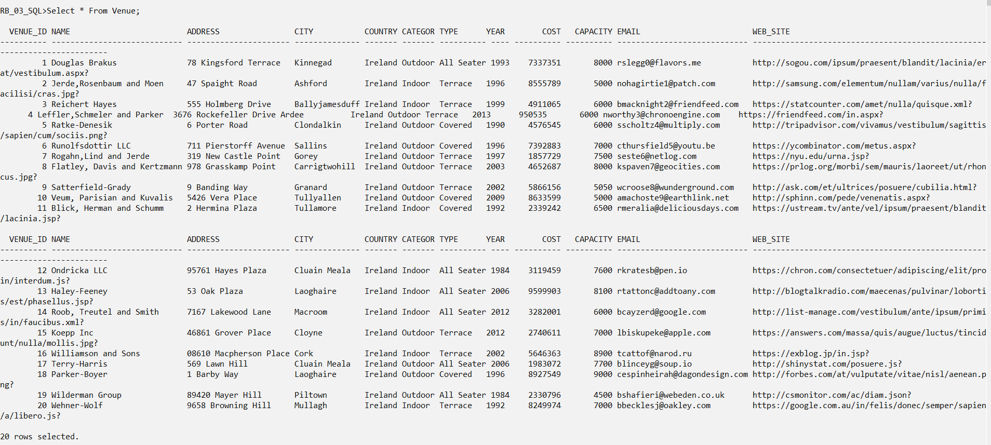

## Newspaper

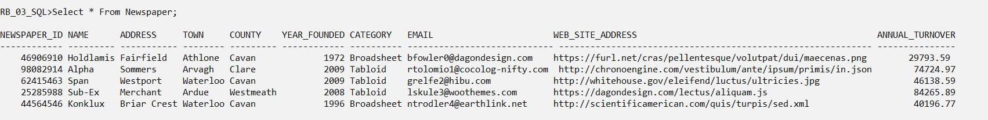

## Sponsor

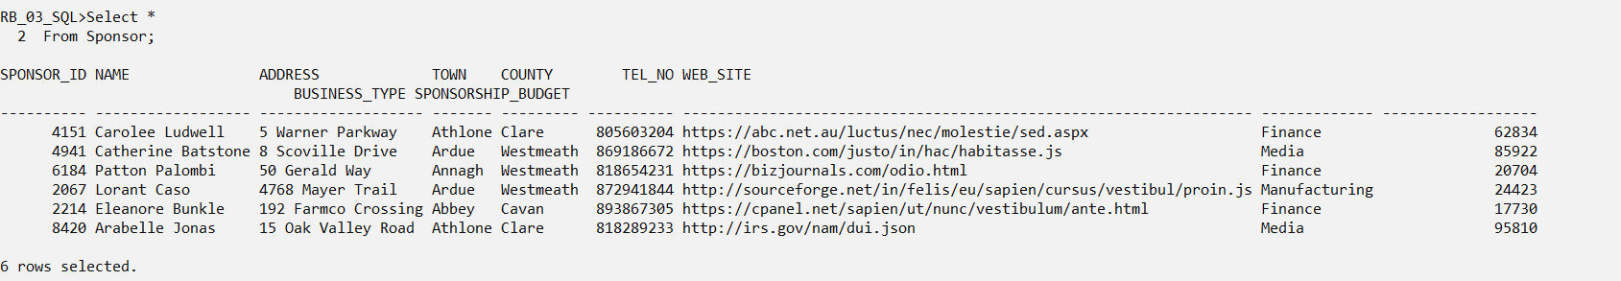

## Journalist

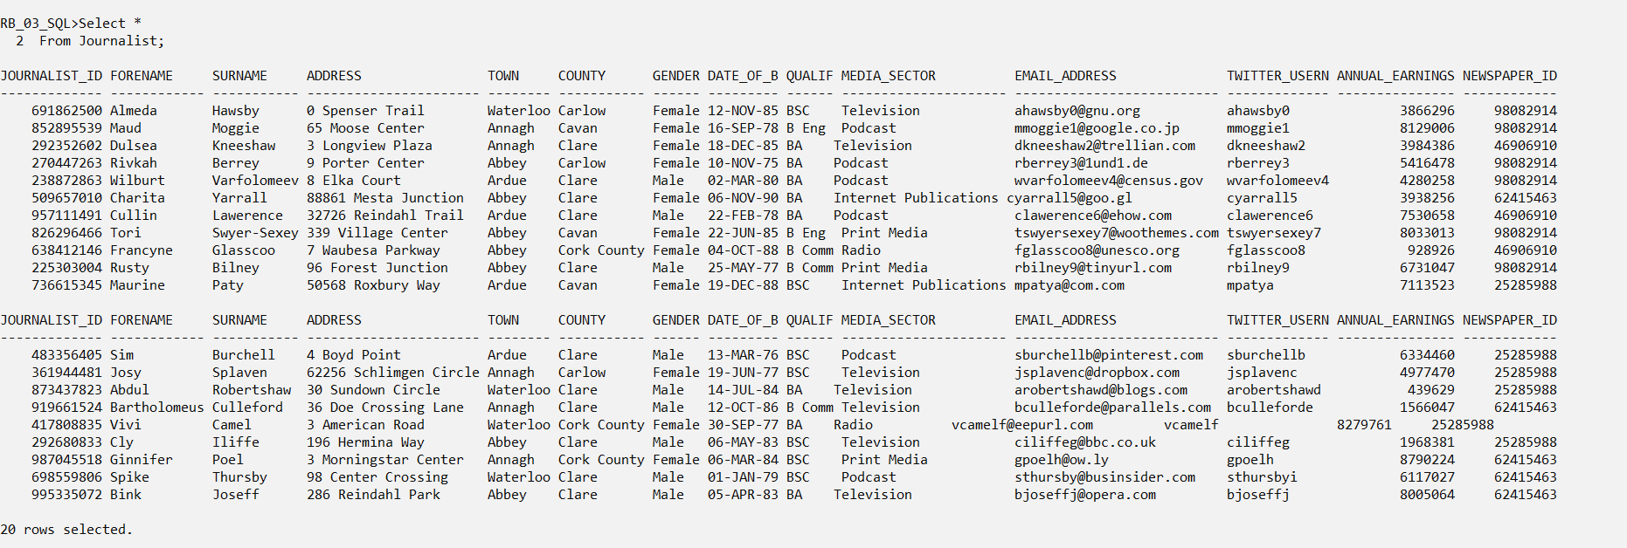

## Concert

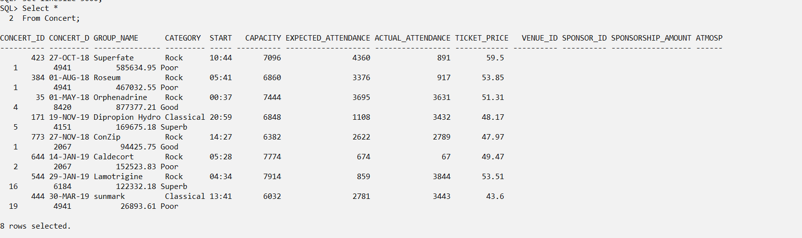

## Concert_Pass

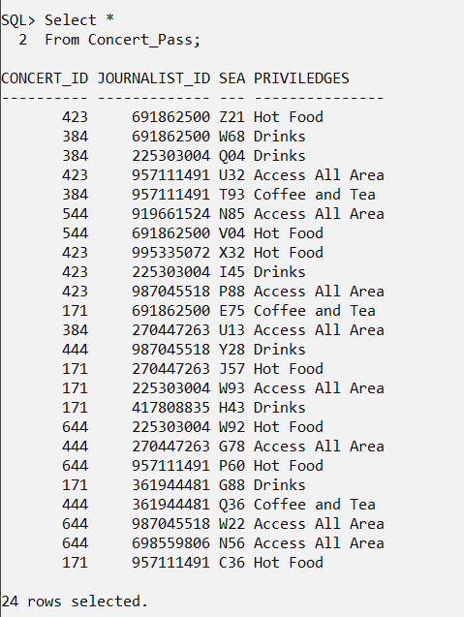

# Queries

1. **Retrieve the Venue name, Address, Category, and type of venue, sponsored by Lorant Caso, for the concert of ConZip. Also display the concert category, start time and how the atmosphere is.**

Solution:

Select V.Name, V.Address, V. Category, V.Type, C.Group_Name, C.Category, C.Start_Time, C.Atmosphere

From Venue V, Sponsor S, Concert C

Where V.Venue_Id = C.Venue_Id

And C.Sponsor_Id = S.Sponsor_Id

And S.Name = ‘Lorant Caso’

And C.Group_Name = ‘ConZip’;

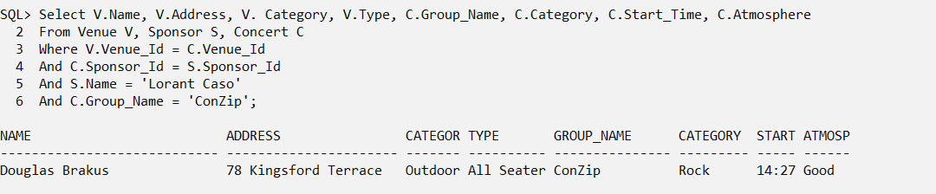

1. **What is the maximum ticket price for a concert? Also, what is the capacity of the concert and how many people actually attended the concert.?**

Solution:

Select Ticket_Price, Capacity, Actual_Attendance

From Concert

Where Ticket_Price =

(Select Max(Ticket_Price)

From Concert);

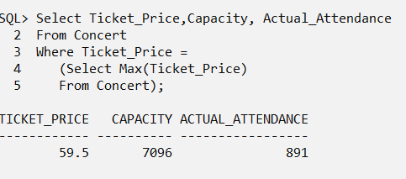

1. **Display name, qualifications and media sector of the journalists, along with their seat numbers for Superfate concert or a sunmark concert.**

Solution:

Select J.Forename, J.Surname, J.Qualification, J.Media_Sector, CP.Seat_Number

From Journalist J, Concert C, Concert_Pass CP

Where J.Journalist_Id = CP.Journalist_Id

And C.Concert_Id = CP.Concert_Id

And C.Group_Name In (‘Superfate’, ‘sunmark’);

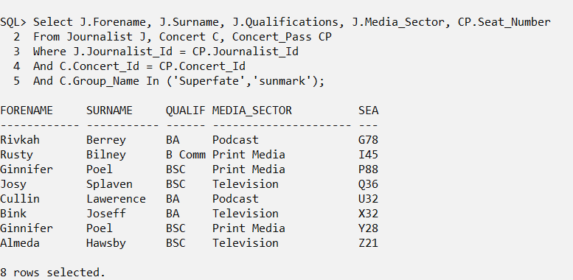

1. **Display the Journalist name, Media sector, Newspaper name whose Annual turnover is greater than the average annual turnover, where the sector is tabloid.**

Solution:

Select J.Forename, J.Surname, J.Media_Sector, N.Name

From Newspaper N, Journalist J

Where J.Newspaper_Id = N.Newspaper_Id

And J.Media_Sector =

And N.Annual_Turnover >

(Select Avg(N.Annual_Turnover)

From Newspaper N);

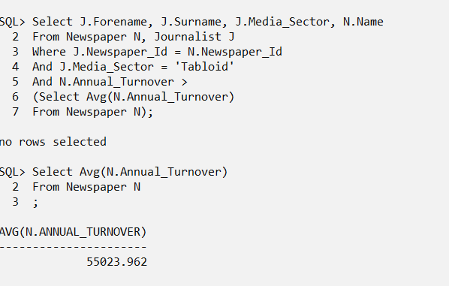

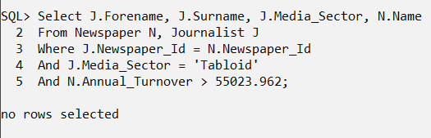

1. **Display the names and qualifications of every Journalist who either works for a newspaper or not**.

Select J.Forename, J.Surname, J.Qualifications, N.Name

From Newspaper N, Journalist J

Where N.Newspaper_Id = J.Newspaper_Id(+);

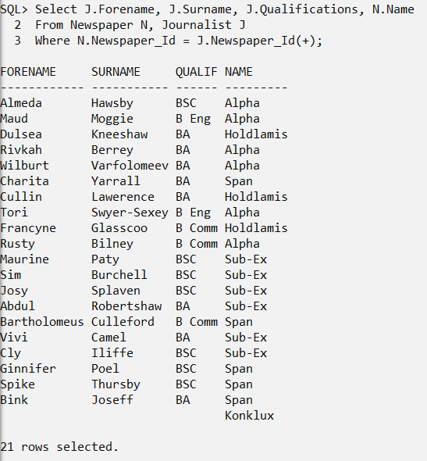

1. **Display the concert name, ticket price and date for which the sponsorship amount is greater than the combined of sponsored amount for the concert by the sponsors.**

Select C.Group_Name, C.Ticket_Price, C.Concert_Date, C.Sponsorship_Amount

From Sponsor S, Concert C

Where C.Sponsor_Id = S.Sponsor_Id

And C.Sponsorship_Amount >

(Select Sum(S.Sponsorship_Budget)

From Sponsor S);

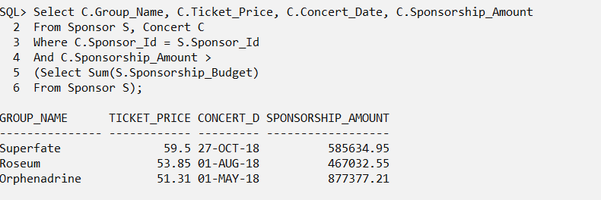

1. **Display the name, city, country, type and cost, where the type of venue is not All seater and the cost for the functioning of the venue is greater than at least one sponsorship amount by some sponsors**.

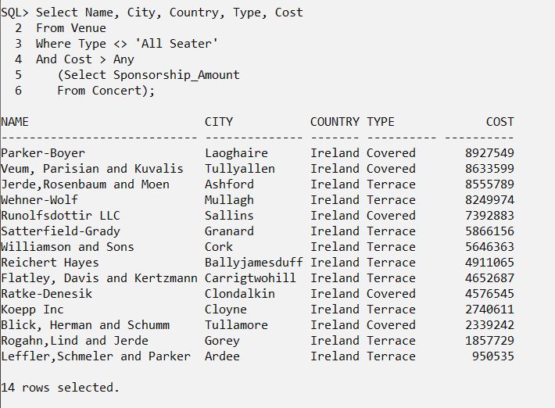

1. **Display the name, the city, country , type and cost of functioning venue where the type of venue is not terrace and the cost is greater than all the sponsorship amount required for the functioning of the concert.**

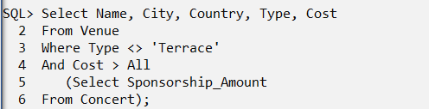

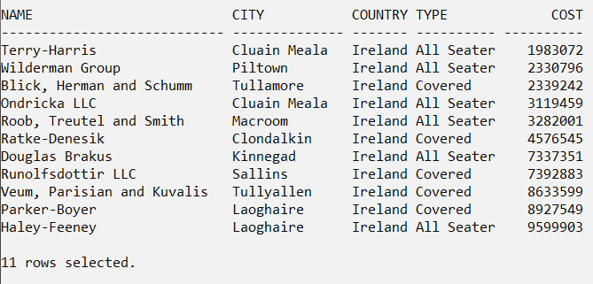

1. **Update the Atmosphere values to ‘Dull’ if the sponsorship amount for the concert is greater than all the combined sponsorship budget by all the sponsors**.

Update Table Concert

Set Concert.Atmosphere = ‘Dull’

Where Sponsorship_Amount <

(Select Sum(Sponsorship_Budget)

From Sponsor);

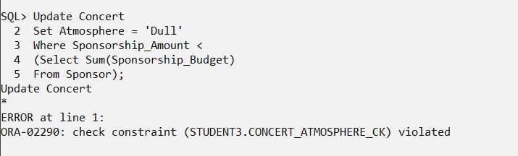

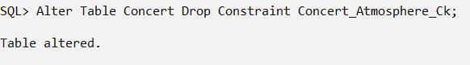

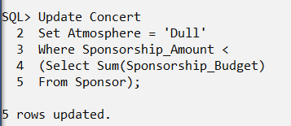

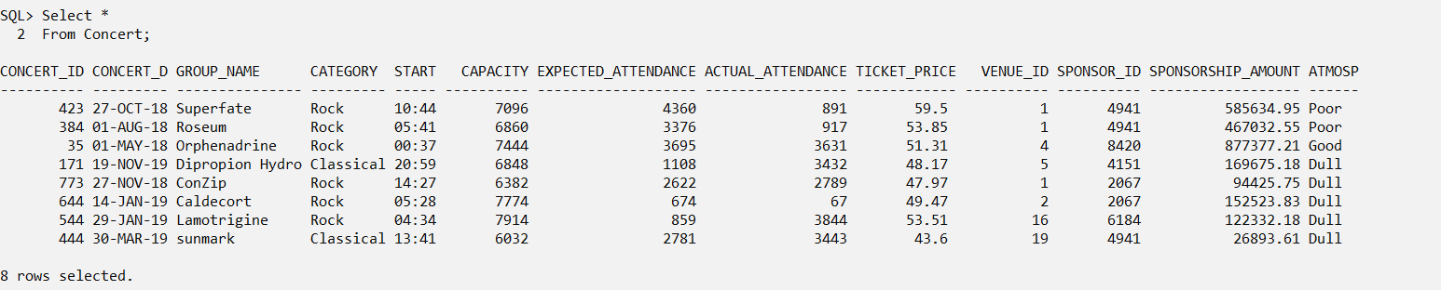

1. **Create a view for journalist name, address and category who works for a newspaper company containing ‘nk’.**

Create View Newspaper_Journalist As

Select J.Forename, J.Surname, J.Address, N.Category

From Newspaper N, Journalist J

Where J.Newspaper_Id = N.Newspaper_Id

And N.Name Like ‘%nk%’;

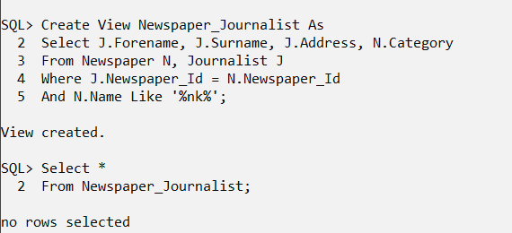

1. **Grant manipulation permissions to two other users.**

